**Exercise**

1. import java.util.Scanner;  
   public class Main  
   {  
   public static void main(String[] args)  
   {  
   int overs;  
   Scanner s=new Scanner(System.in);  
   System.out.println("Enter the number of overs");  
   try  
   {  
      overs=s.nextInt();  
      int[] runs=new int[overs];  
      System.out.println("Enter the number of runs for each over");  
       for(int i=0;i<overs;i++)  
       {  
          runs[i]=s.nextInt();  
      }  
      System.out.println("Enter the over number");  
      int input=s.nextInt();  
      System.out.println("Runs scored in this over : "+runs[input-1]);  
   }  
   catch(Exception e)  
   {  
      System.out.println(e);  
   }  
     
   }

}

**Output:**

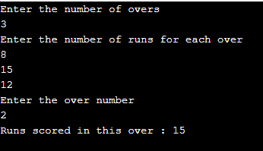

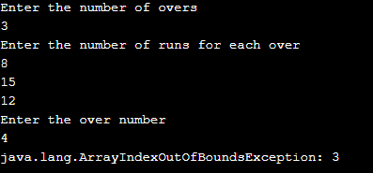

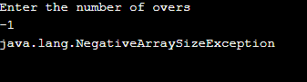

1. import java.util.*;  
   import java.util.Scanner;  
   class InvalidAgeRangeException extends Exception  
   {  
       InvalidAgeRangeException()  
       {   }  
   }  
   public class Main  
   {  
   public static void main(String[] args)  
   {  
   Scanner s=new Scanner(System.in);  
   int age;  
      String name;  
      System.out.println("Enter the player name");  
      name=s.nextLine();  
      System.out.println("Enter the player age");  
      age=s.nextInt();  
      try  
      {  
      validate(name,age);  
   }  
   catch(Exception e)  
   {  
      System.out.println("Custom Exception : "+e);  
   }  
   }  
   static void validate(String name,int age) throws InvalidAgeRangeException  
   {  
      if(age<19 || age>39)  
      {  
          throw new InvalidAgeRangeException();  
      }  
      else  
      {  
          System.out.println("Player name : "+name+"\nPlayer age : "+age);  
      }  
   }  
   }

**Output:**

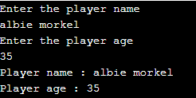

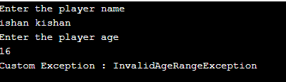

1. import java.util.Scanner;  
   class TeamNameNotFoundException extends Exception  
   {  
       TeamNameNotFoundException(String s)  
       {  
           super(s);  
       }  
   }  
   class Main  
   {  
       static String w_name;  
       static String r_name;  
       static String[] contestant={"Chennai Super Kings","Deccan Chargers","Delhi Daredevils","Kings XI Punjab","Kolkata Knight Riders","Mumbai Indians","Rajasthan Royals","Royal Challengers Bangalore"};  
       static void validate(String name) throws TeamNameNotFoundException  
       {  
           int len=contestant.length;  
           int l=0;  
           for(int i=0;i<len;i++)  
           {  
               String d=contestant[i];  
               if(name.equals(d))  
               {  
                   l++;  
                   break;  
               }  
           }  
           if(l==0)  
           {  
               throw new TeamNameNotFoundException("Entered team name is not part of IPL Season 4");  
           }  
       }  
       public static void main (String[] args)  
       {  
           int flag=1;  
           Scanner s=new Scanner(System.in);  
           System.out.println("Enter the expected winner team name of IPL Season 4 ");  
           w_name=s.nextLine();  
           try  
           {  
               validate(w_name);  
           }  
           catch(Exception e)  
           {  
               System.out.println(e);  
               flag=0;  
           }  
           if(flag==1)  
           {  
               System.out.println("Enter the expected runner team name of IPL Season 4 ");  
               r_name=s.nextLine();  
               try  
               {  
                   validate(r_name);  
               }  
               catch(Exception e)  
               {  
                   System.out.println(e);  
                   flag=0;  
               }  
           }  
           if(flag==1)  
           {  
               System.out.println("Expected IPL Season 4 winner: "+w_name);  
               System.out.println("Expected IPL Season 4 runner: "+r_name);  
           }  
       }  
   }

**Output:**

